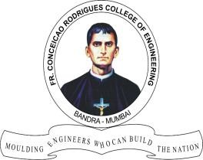**Hardik Prajapati - 9152**

**Fr. CONCEICAO RODRIGUES COLLEGE OF ENGINEERING ( FrCRCE)**

**Department of Electronics and Computer Science (ECS)**

**1. Display Interfacing**

**Course, Subject & Experiment Details**

**Academic year**

**Course Semester**

**Experiment Type**

**2022 – 2023**

**T.E. (ECS) VI**

**Coding**

**Estimated Time**

**Subject Name Chapter Title**

**Subject Code**

**02 Hours**

**Embedded systems and RTOS Display interfacing**

**ECC 601**

**Aim & Objective of Experiment**

1. To write and execute an assembly language program to interface an alphanumeric LCD to the 8051 (Using KEIL Micro-Vision)
2. To design the system (using Proteus VSM) and show simulation results.

**Theory:**

Liquid Crystal Display (LCD) consists of rod-shaped tiny molecules sandwiched between a flat piece of glass and an opaque substrate. These rod-shaped molecules in between the plates align into two different physical positions based on the electric charge applied to them. When electric charge is applied they align to block the light entering through them, whereas when no-charge is applied they become transparent. Light passing through makes the desired images appear. This is the basic concept behind LCD displays. LCDs are most commonly used because of their

advantages over other display technologies. They are thin and flat and consume very small

amount of power compared to LED displays and cathode ray tubes (CRTs).

# Advantages:

* Consumes less power and generates less heat.
* Saves lot of space compared picture tubes due to LCD's flatness.
* Due to less weight and flatness LCDs are highly portable.
* No flicker and less screen glare in LCDs to reduce eyestrain.

# Drawbacks:

LCDs cannot form multiple resolution images.

The contrast ratio for LCD images is lesser than CRT and plasma displays.

Due to their longer response time, LCDs show ghost images and mixing when images change rapidly. The narrow viewing angle of an LCD weakens the image quality in wider viewing angles.



**Algorithm:**

**Fr. CONCEICAO RODRIGUES COLLEGE OF ENGINEERING ( FrCRCE)**

**Department of Electronics and Computer Science (ECS)**

//Name: Hardik Prajapati

//Roll NO. 9152 ECS

#include <reg51.h> //importing header file for 8051

sfr ldata=0X90; //setting port P1 for communication with LCD sbit rs=P2^0; //assigning rs pin of lcd to P2.0

sbit rw=P2^1; //assigning rw pin of lcd to P2.1 sbit en=P2^2; //assigning en pin of lcd to P2.2

void delay (unsigned int itime); //subroutine for producing delay of 1ms

void lcdcmd (unsigned char value); //subroutine for sending commands to lcd void lcddata (unsigned char value); //subroutine for sending data to lcd

void delay (unsigned int itime)

{

unsigned int i,j;

for (i=0;j<itime;i++)

{

for(j=0;j<1275;j++);

}

}

void lcdcmd (unsigned char value)

{

ldata=value; //sending commands to port1 rs=0; //to set the lcd in command mode rw=0; //to set the lcd in write mode

//to give a high to low pulse to en pin for latching the data on lcd en=1;

delay(1); en=0; return;

}

void lcddata (unsigned char value)

{

ldata=value; //sending data to port1 rs=1; //to set the lcd in data mode rw=0;

en=1; delay(1); en=0; return;

}

void main()

{

lcdcmd(0X38); //declaring that it is a 16x2 lcd each block is 5x7 matrix delay(50); //adding delay of 50ms giving time for lcd to execute the command

lcdcmd(0X0E); //lcd on and cursor blinking delay(50);

lcdcmd(0X01); //clear the lcd delay(50);

lcdcmd(0X06); //increment the cursor(left to right) delay(50);

lcdcmd(0X82); //start printing from first position delay(50);

lcddata('E');

delay(50); //adding delay of 50ms giving time for lcd to print the character lcddata('S');

delay(50); lcddata('R'); delay(50); lcddata('T'); delay(50); lcddata('O'); delay(50);

lcddata('S'); delay(50);

}

**KEIL Micro-Vision Output:**

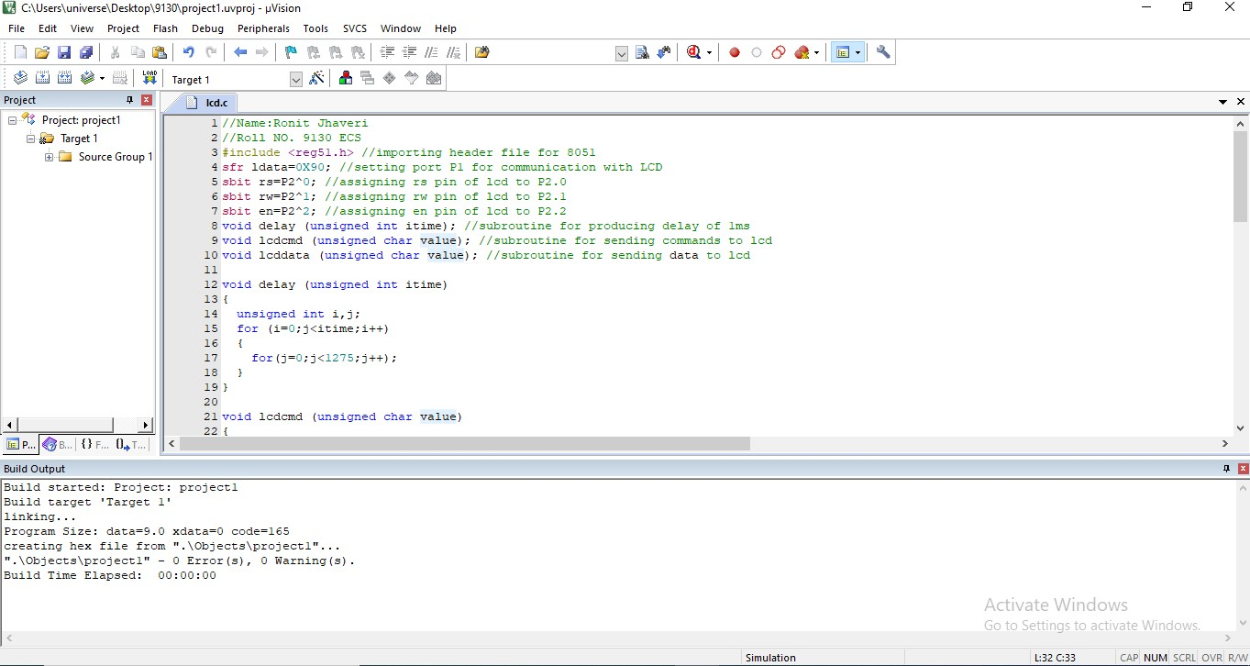

**Proteus VSM Output:**

